ROYAL OAK INTERNATIONAL SCHOOL
SR. SEC. CBSE AFFILIATED
HOLIDAY HOME WORK (SESSION 2018 - 19)
Class VII
Name ____________________ Roll No. __________ Sec._______
Please note the following :
- Summer vacations will commence from 17th May 2018(Thursday) till 29th June 2018(Friday) both days inclusive.
- The school will re-open on 2nd July, 2018(Monday)
- Schedule for the submission of HHW for all class is as follows :
English : 09/07/2018
Hindi : 10/07/2018
Maths : 11/07/2018
Science : 12/07/2018
SSt. : 13/07/2018
- For Computer, Gk, Sanskrit, Art & Craft (2nd week of july) dates will be given in the classes only by the subject teachers.
- Summer HHW -5marks will be added as an Activity marks in Term - I

WISHING YOU ALL A VERY FRUITFULL AND ENJOYABLE VACATION
HAPPY HOLIDAYS
Attached

Your holiday homework this year is combined with varied aspects of the language. It has been designed to ensure that you enjoy and learn at the same time.
English
Attached
Attached
- Do your Holiday Homework in a separate thin notebook .
- Do neat work and present it with an attractive cover page.
- Be creative. Be original.

I. Read Part II of the novel ‘A Tale of Two Cities’ by Charles Dickens.
a) Write the main characters you found.
b) Which character is very close to your heart and why?
c) Write a summary in about 100 words.
d) Find one anonym and one synonym for 10 new words you found in this part of the novel.
e) Present your work creatively.

II. Mother’s Day was round the corner. You celebrated with much glee and admiration. Write a letter to your friend depicting your heartfelt joy for getting such a wonderful mother.

III. These days there is rampant fluctuation of voltage in your locality. From you experience write a paragraph on ‘A day without electricity’.

IV. Write a short note on any one Indo Anglican writer or poet and present it beautifully on A 4 Size sheet.

GRAMMAR

I. Make a Tense Chart of Present Tense using all three persons and the verb ‘write’. It is important to make affirmative, negative and interrogative sentences.

II. Do the exercises of Grammar Section in Together with English.
Determiners:Page no. C 19 - C22, C30 - C32

III. Fill in the blanks with the correct determiner.
a) Our garden looks awful this summer. There are too ……………. weeds.
much some many
b) There aren’t ………………. flowering plants in our garden.
many no much
c) How ……………….. pages did you read?
many more much
d) They say …………………. knowledge is a dangerous thing.
little a little the little
e) I am having ……………….. trouble passing my driving exam.
lot of a few a lot of
f) ...................... people can afford a home these days.
Few fewer Little
g) You have ……………….. patience.
little a few few
h) She earns ..................... money than I do.
less fewer lesser

i) . ..................... of the information proved to be outdated.
Some any Many
j) I didn’t use ……………….. fertilizer last spring.
much many most

IV. Insert appropriate articles if required.
i. I like ---------------- blue T-shirt over there better than------------------- red one.
ii. Their car does 150 miles ----------------- hour.
iii. Where's ----------------- USB drive I lent you last week?
iv. Do you still live in------------------------- Bristol?
v. Is your mother working in ----------------- old office building?
vi. Carol's father works as------------------------ electrician.
vii. The tomatoes are 99 pence-------------------------- kilo.
viii. What do you usually have for------------------------ breakfast?
ix. Ben has ----------------------- terrible headache.
x. After this tour you have ------------------ whole afternoon free to explore the city.
V. Insert the correct form of Present Tense using the verbs in bracket. One example is given below.
a) I live (live) in Edinburg.
b) She is a teacher. She ________________ (work) at primary school.
c) “Are you a singer?”
“No, I am a pilot. I ______________ (fly) aeroplanes.”
d) Raman ________________ (study) Science at university.
e) They _________________ ___________ ( leave) for the airport a little while before.
f) ____________ your father _______________ (know) that you are here.
g) We __________________ (go) to the swimming pool every weekend.
h) John and Mary _______________ (wait) for you since morning.
i) Every year my mother and I __________________ (go) to my Granny’s house, but this summer we ____________________________ (go) to Shimla.
j) I usually _____________________ (have) my breakfast at 7 a.m.,but today I____________ (have) it at 7.30 a.m.

VI. Jumbled sentences.
1. a) Last/ year/ President/ Obama/ of/ the/ USA/ India/ visited/ the

b) He/ the / went/ Humayun/ to/ Tomb/ see/ with/wife/his.

c) Rajghat/ also/ visited/ the/ He.

2. a) could/one/the cold/almost/bear/biting wind/outside/blowing

b) as it/ people/tostay/preferred/inside/bitterlycold/theirhouses/was/outside

c) brewing up/seemed to/a storm/be

3. a) commuting/the/for/bicycle/invented/is one/ever/of the/ devices/simplest

b) forward /own/your/bike/propels/muscle power/your

c) the/enjoys/benefits/cycling/everyone/health/of

VII. Practice your grammar skills throughout the holidays. Use some or all of the following
websites:

• http://www.bbc.co.uk/bitesize/ks2/english/
• http://www.englisch-hilfen.de/en/exercises_list/alle_grammar.htm
• http://www.testdesigner.com/questions/Grammar/Grade_7
• http://www.learnenglish.britishcouncil.org/en/english-grammar/

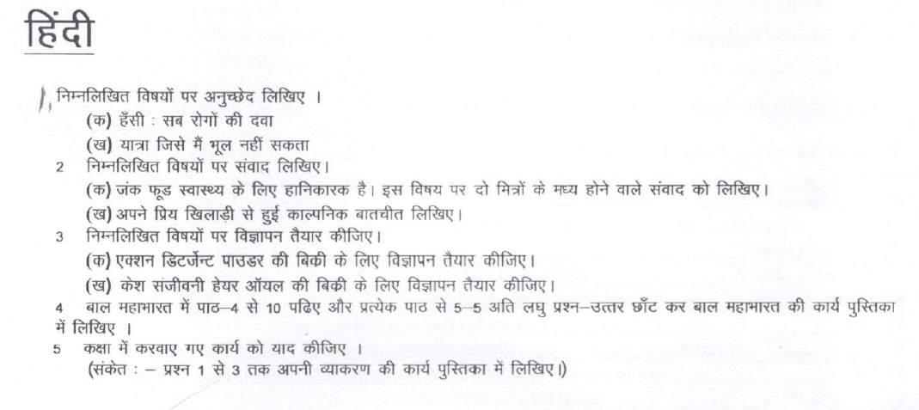
Maths
Topic: Integers, Fractions & Decimals
Q1. Find the value of:
(a) 18946 × 99 – (-18946) (b) 1569 × 887 – 569 × 887

Q2. Verify the following:
(a) 19 × {7 + (-3)} = 19 × 7 + 19 × (-3)
(b) (-23) × {(-5) + (+19)} = (-23) × (-5) + (-23) × (+19)

Q3. Fill in the blanks:
(a) The product of a positive integer and a negative integer is a _____________ integer.
(b) The product of two negatives is a _____________ integer.
(c) The product of a negative integer and zero is ____________.
(d) The negative of an integer is the same as multiplying the integer by ____________.

Q4. A man had Rs. 10,000 in his bank account. He withdrew Rs. 500 a day for 10 days continuously. Find out the balance in his account after 10 days.

Q5. A shopkeeper earns a profit of Rs.2 by selling one pen and incurs a loss of 50 paise per pencil while selling pencils of her old stock.
(a) In a particular month she incurred a loss of Rs.10. In this period, she sold 45 pens. How many pencils did she sell in this period?
(b) In the next month, she earns neither profit nor loss. If she sold 80 pens, how many pencils did she sell?

Q6. The temperature at 2 p.m. was 22˚C above zero. If it decreases at the rate of 3˚C per hour until mid-night, at what time would the temperature be 2˚C below zero?

Q7.Write any three pairs if integers (a,b) such that a ÷ b = -2

Q8. In a class test (+3) marks are given for every correct answer and (-2) marks are given for every incorrect answer and no marks for not attempting any question. (i) Radhika scored 20 marks. If she has got 12 correct answers, how many questions has she attempted incorrectly? (ii) Mohini scores -5 marks in this test, though she has got 7 correct answers. How many questions has she attempted incorrectly?

Q9. If a clock has been losing 3 minutes every day, then how much fast was it six days ago?

Q10. Simplify:
(a) (-5) – (-48) ÷ (-16) + (-2) × 6 (c) 28 – 5 × 6 + 2
(b) (-3) + (-8) ÷ (-4) -2 × (-2) (d) 16 + 8 ÷ 4 -2 × 3

Q11. Raheem and Ajmal went for a picnic. Their mother gave them a water bottle that contained 5 litres of water. Ajmal consumed $\frac{3}{5}$ part of water. Raheem consumed the remaining water.

Q12. Anu reads $\frac{2}{7}$ part of a book in 1 day. How much part of the book will she read in $\frac{5}{2}$ days?
Q13. In a school, $\frac{4}{5}$ of the students are boys. If the school has a strength of 620 students, how many girls are there in the school?

Q14. Vijay had $\frac{5}{8}$ of a cake. He ate $\frac{2}{3}$ of it. What part of the whole cake did Vijay eat?
Q15. A paper strip of length $\frac{15}{2}$ cm is cut in to two pieces. What is the length of each piece?
Q16. If the cost of 2$\frac{3}{4}$ kg of mangoes is Rs. 88, what is the cost of one kg of mangoes?
Q17. Find the product:
(a) 2.47 × 100 (d) 10.03 × 100
(b) 5.7 × 4 (e) 0.03 × 1000
(c) 43.076 × 1000 (f) 12.031 × 100

Q18. Renu weighs 27.5 kg. Her mother is 1.12 times heavier than her. Find her mother’s weight.

Q19. If 25 tins of ghee weigh 412.5 kg, find the weight of 1 tin.

Q20. The product of two decimals is 14.837. If one of them is 4.01, what is the other decimal?

Q21. Simplify:
(a) 6$\frac{7}{43}$ - $\frac{148}{86}$ (c) 8$\frac{8}{15}$ of $\frac{5}{16}$ ÷ $\frac{3}{8}$
(b) $\frac{5}{23}$ + 3 + 7$\frac{15}{69}$ (d) 1$\frac{7}{8}$ ÷ 1$\frac{1}{2}$ of 8$\frac{1}{3}$ ÷ 1$\frac{1}{2}$

Q22. A water tank holds 2567 litres water. 378 litres 240 ml of water flows out. How much water is left in the tank? Give your answer in terms of litres.

Q23. Three parcels weigh 5$\frac{2}{7}$ kg, 4 kg and 5$\frac{4}{5}$ kg respectively. How much is the total weight short of 20 kg?

Q24. The area of a rectangle of length 7.1 cm is 17.75 sq cm. Find its breadth.

Q25. The monthly salary of 4 workers of a factory is Rs. 10226.20. Find the salary of 1 worker.

Note : Home work should be done on a separate notebook. Submit it on 4th july, 2018 to the subject teacher
1. Learn all tables 2 to 20
2. Learns and write all basic formulas.
3 Make a Maths Magazine in scarp book
4. Make a chart on integers.

Science
Work sheet on Fibre to Fabrics
Fill up the blanks :
1. Wool is obtained from the ______________ of the sheep or yak.
2. __________ is the name of the breed of sheep from which we get Kashmiri shawls.
3. By the process of _____________ we get off springs with special characters.
4. Washing of sheared skin is known as ______________
5. In __________ the hairs of different textures are separated.
6. Silk fibre is made up of a __________
7. The silk fibre is obtained from the covering of pupa known as ______________
8. The larva of silk worm are called______________
9. Inside cocoon, the pupa develops into ______________
Name the following:
1. Two wool giving animals.
2. Two Indian breeds of sheep.
3. Two types of silk.
4. Name the most common silk.
5. Bacterium which causes sorter’s disease.
6. Process of taking out silk – threads from cocoon.
Write true or false:
1. Soft silk yarn is strong as comparable thread of steel.
2. Shearing hurts the sheep.
3. Small fluffy fibres are called burrs.
Answer briefly:
- Name the country which leads the world in silk production
- Cultivation of mulberry leaves is called
- Rearing honey bees is called
- Name three animals which yield wool
- Name 4 major wool producing countries
- The process of removing fleece from the body of sheep
Answer the following questions:
1. Describe how silk worm enters the pupa stage.
2.. Describe how silkworms are reared for their cocoons.
3. What are caterpillars?

ACTIVITTY: Stick the pictures of wool yielding animals on A3 size sheet and also of silkworm. Also stick the various types of wool and silk on the same paper and mention their names.

SOCIAL SCIENCE
- Prepare a project file on the topic “Famous Mughal Emperor’s who ruled over India (Between 1526 to 1707 AD)”.
1. Administration 2. Agriculture and Irrigation 3. Paintings 4. Architecture
Must begin the project by including the following parameters :
- Cover page with your name , roll no, academic year.
- Acknowledgement ( giving credit to those who helped you in this project)
- Project overview ( brief idea about the project )
- Content sheet ( 8 to 10 with relevant photographs )
- Conclusion
- Bibliography ( the book you read and the website you visited for the project )
- Design Peacock Throne describing its silent features in fair note book of History.
- Prepare complete syllabus for Periodic Assessment I .

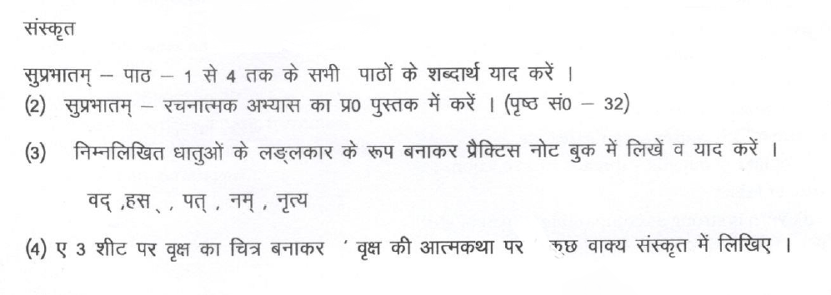

Computer
Roll No. (1 to 11):- Draw different types of charts and explain. Use scrap book.
Roll No. (12 to 23):- Make a college of typesof Virusesand Anti viruses.
Roll No. (24 onward):- Make a college of different type of Windows OS.
- Create a Spreadsheet in MS Excel on mark sheet and Find out total, percentage, max, min, average, count, grade and Result as pass or fail, Take printout of it.

- Learn Lesson 1 and 2.

G.K
1. Read the newspaper daily and write two main important headlines every day, with one
Sports news and paste the related pictures in G.K. notebook. (From 21th May to 05th June 2018)

2. (a) Many plants grow from seeds but some plants are seedless plants, they do not grow from seeds. On the basis of this make a collage on seedless plants on A3 size sheet and mention their names also.
(b) Paste the pictures of “Top 10 green cities of India” and write few lines on each of them.
( Do this work in your GK notebook)

3. India won many Gold medals in the XIX Common Wealth Games 2014 and 2018. Paste all the pictures of Gold and Silver medalists and mention their names.

Art/Craft
Summer Break : Flower Bunch with colour paper

